**Assignment 4**

**Maria Andrea Domínguez Osorio**

1. **GitHub Repo**

The repository was created and can be found in the following link:

<https://github.com/mariadominguez97/RDD>

1. **Summary**

Hansen wants to determine the effects of punishment severity in drunk driving and wants to determine whether harsher punishments and sanctions reduce future drunk driving. For this, he uses blood alcohol content (BCA) thresholds, where punishments are determined using BAC levels which can’t be manipulated either by drivers or police, which is why this works as a perfect cutoff for the investigation. Additionally, for the data the study used the administrative records on 512,964 DUI BAC tests in the state of Washington from 1995 to 2011, specifically data available from 1999 to 2007 to analyze the causal effect of having a BAC above either the 0.08 or 0.15 threshold on whether the person received another DUI within four years of the original BAC test.

For his research design, he uses a regression discontinuity approach where the cutoff is the 0.08 and the 0.15 threshold, and as for the running he uses the minimum measure registered for the driver (considering that this measure is taken twice as required by law). The outcome variable for the study is recidivism, which measures if the person receiving de punishment appeared again in the data 4 years later. Finally, he concludes that receiving punishments and sanctions does reduced repeated drunk driving offences, both in the short and long term. For example, the study finds that having a BAC over the 0.08 threshold generates a 2 percent point decline in repeat drunk driving in the next four years while punishments for a BAC over the 0.15 legal limit reduces recidivism in another percentage point.

1. **Dummy for BAC >= 0.08**

The dummy variable was created, the command can be found in the do file for the assignment in the RDD repository, the variable created is called D, since a BAC above the legal limit determined whether the person received the treatment (In this case a DUI).

1. **Checking for manipulation**

The test that should be used to check for manipulation on the running variable is the McCrary density test. According to this test, if the running variable wasn’t manipulated (null hypothesis), the density should be continuous at the cutoff. Therefore, this test check for density continuity at the cutoff point. For this case, the test was carried out using bac1 as the running variable and manipulation was checked for the 0.08 cutoff using the rddensity command in stata. This command gives two results, the first one reports a p-value of 0.5936 which is the same as the one obtained by Hansen. However, the second p- value which implements inference based on robust bias-correction corresponds to a value of 0.0276 so it is concluded that the data exhibits evidence for sorting on the running variable. Additionally, below the histogram and the plot for the density test are shown, where a slight discontinuity can be seen, which again gives evidence for sorting on the running variable.

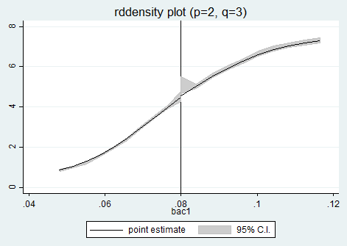

Figure 1. Rddensity plot for Manipulation Test

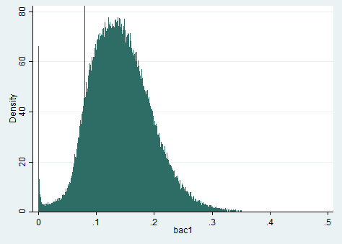

Figure 2. Histogram for running variable BAC

1. **Checking for covariate balance with regressions**

To check for covariate balance, the following regression was run using the controls for White, Male, Age and Accident as the dependent variable

$y_{i}=$ γ+ α1*Di* + α2*BAC1i* + α3*BAC1i* x *Di* + *u*

Firstly, a global regression using all the available data was run. In table 1, it is shown that the coefficients for the treatment and the interaction of the running variable and the treatment was statistically significant for the variables Accident and Age, and the coefficient of the treatment in the variable Male is also significant. These results lead to the conclusion that the covariates are not balanced. In addition, a local regression was made but only considering data with values +/- 0.05 around the cutoff. The results for this regression are shown in table 2. It is shown that the coefficient for the treatment is no longer significant for any of the variables. However, the interaction between treatment and running variable is significant for all of them. Because of this, it is reiterated that the covariates are not balanced at the cutoff.

Table 1. Covariate balance global regression

|  |  |  |  |  |
| --- | --- | --- | --- | --- |
|  | (1) | (2) | (3) | (4) |
| VARIABLES | Male | White | Aged | Accident |
|  |  |  |  |  |
| D | 0.00581 | 0.00407 | -1.115*** | -0.00701** |
|  | (0.00421) | (0.00368) | (0.121) | (0.00314) |
| BAC | 0.218* | 0.154 | -56.36*** | -1.540*** |
|  | (0.112) | (0.0980) | (3.223) | (0.0977) |
| interaction | -0.311*** | 0.0170 | 83.40*** | 2.656*** |
|  | (0.114) | (0.0994) | (3.268) | (0.0995) |
| Constant | 0.791*** | 0.847*** | 34.06*** | 0.0776*** |
|  | (0.00384) | (0.00338) | (0.111) | (0.00281) |
|  |  |  |  |  |
| Observations | 214,558 | 214,558 | 214,558 | 214,558 |
| R-squared | 0.000 | 0.001 | 0.013 | 0.021 |

Table 2 Covariate balance local regression

|  |  |  |  |  |
| --- | --- | --- | --- | --- |
|  | (1) | (2) | (3) | (4) |
| VARIABLES | Male | White | Age | Accident |
|  |  |  |  |  |
| D | 0.00618 | 0.00570 | -0.140 | -0.00335 |
|  | (0.00567) | (0.00495) | (0.162) | (0.00421) |
| BAC | -0.210 | 0.0788 | -69.16*** | -1.096*** |
|  | (0.240) | (0.210) | (6.844) | (0.178) |
| interaction | 0.307 | 0.0156 | 76.05*** | 1.888*** |
|  | (0.263) | (0.230) | (7.508) | (0.196) |
| Constant | 0.784*** | 0.846*** | 33.92*** | 0.0834*** |
|  | (0.00460) | (0.00401) | (0.131) | (0.00341) |
|  |  |  |  |  |
| Observations | 89,967 | 89,967 | 89,967 | 89,967 |
| R-squared | 0.000 | 0.000 | 0.002 | 0.002 |

1. **Checking for covariate balance with graphs**

The panels for each control variable with linear and quadratic fit were made and are shown below. It was also added a line at point 0.08 of the running variable to show whether a jump in these covariates is visible at the cutoff. As shown below, with the linear fit the confidence intervals for the covariates show that for the variables Accident, Male and White, there is not a significant jump at the cutoff, however for age there evidently is a jump since confidence interval at the left and right of the graph is separated. Moreover, with the quadratic fit all the confidence intervals cross at both sides of the cutoff, which contradicts the results obtained with the linear regression in point 5, since the graphs indicate that the covariates are balanced at the cutoff.

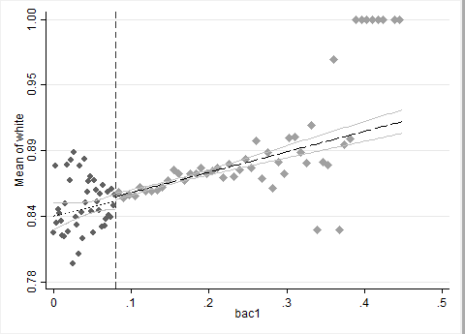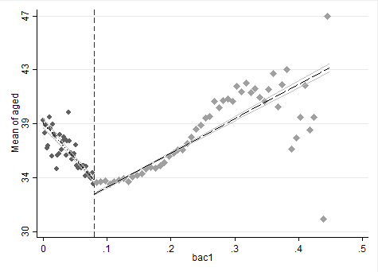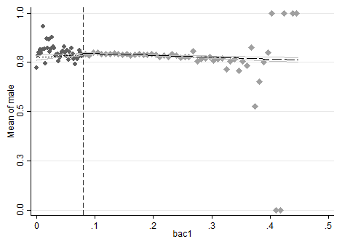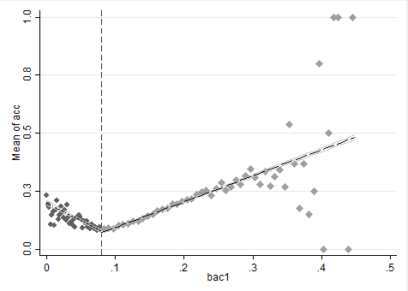

Figure 6. Panel D. White. Linear fit.

Figure 5. Panel C. Age. Linear fit.

Figure 4. Panel B. Male. Linear fit

Figure 3. Panel A. Accident at scene. Linear fit

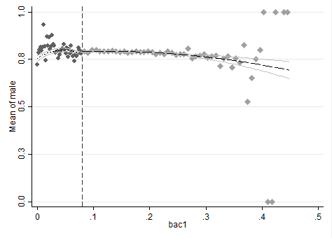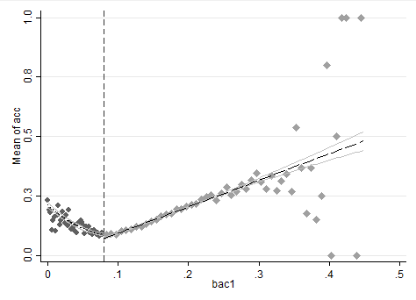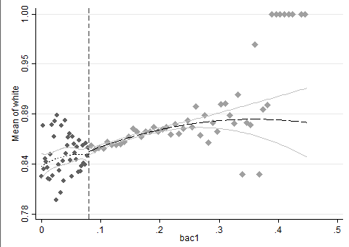

Figure 8. Panel D. White. Linear fit.

Figure 7. Panel A. Accident. Quadratic fit.

Figure 10. Panel D. White. Quadratic fit.

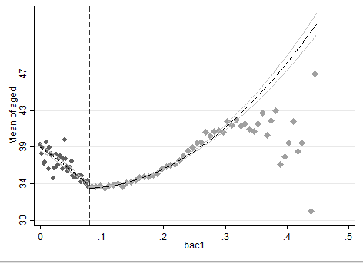

Figure 10. Panel D. White. Quadratic fit.

Figure 9. Panel C. Age. Quadratic fit.

1. **RDD Estimation**

Below, the regressions to evaluate the effect of having a DUI over recidivism in a four-year period are shown. For each of the tables depicted three models were estimated, the first one controlling for the BAC linearly (column 1), the second interacting the BAC with the cutoff linearly (column 2), and the third interacting BACK with the cutoff linearly and as a quadratic (column 3). The equations for the models are shown below, where $y_{i}$ corresponds to the variable recidivism. Additionally, the control variables for Male, Age, White and Accident were added and are also shown in the results. Finally, the models were repeated twice doing different local regressions. Table 3 shows the regressions for a bandwidth of 0.03 to 0.13 while table 4 shows the results of the regression with a bandwidth of 0.055 to 0.105.

$y_{i}=$ X’γ+ α1*Di* + α2*BAC1i*

$y_{i}=$ X’γ+ α1*Di* + α2*BAC1i* + α3*BAC1i* x *Di* + *u*

$y_{i}=$ X’γ+ α1*Di* + α2*BAC1i* + α3*BAC1i* x *Di* + α4 $( {BAC1i x Di)}^{2}$*u*

As can be seen in the results, the effect of having a DUI over recidivism in the next four years is statistically significant at the $α=0.01$ level. Moreover, the coefficients for the treatment is negative, which proves the conclusion obtained by Hansen that punishments reduce recidivism in drunk drivers. Lastly, looking at panel B, the conclusion remains the same for a smaller bandwidth.

Table 3. (Table 3 Panel A) Bandwidth 0.03 to 0.13

|  |  |  |  |
| --- | --- | --- | --- |
|  | (1) | (2) | (3) |
| VARIABLES | Linear control | Linear interaction | Quadratic interaction |
|  |  |  |  |
| D | -0.0273*** | -0.0240*** | -0.0201*** |
|  | (0.00403) | (0.00435) | (0.00529) |
| BAC | 0.321*** | -0.0429 | -0.0429 |
|  | (0.0748) | (0.187) | (0.187) |
| Interaction |  | 0.438** | 0.0171 |
|  |  | (0.204) | (0.385) |
| Quadratic interaction |  |  | 8.014 |
|  |  |  | (6.276) |
| male | 0.0332*** | 0.0332*** | 0.0332*** |
|  | (0.00233) | (0.00233) | (0.00233) |
| white | 0.0162*** | 0.0162*** | 0.0162*** |
|  | (0.00280) | (0.00280) | (0.00280) |
| aged | -0.000847*** | -0.000854*** | -0.000854*** |
|  | (8.49e-05) | (8.50e-05) | (8.50e-05) |
| accident | 0.00444 | 0.00421 | 0.00418 |
|  | (0.00345) | (0.00345) | (0.00345) |
| Constant | 0.111*** | 0.106*** | 0.106*** |
|  | (0.00480) | (0.00535) | (0.00535) |
|  |  |  |  |
| Observations | 89,967 | 89,967 | 89,967 |
| R-squared | 0.004 | 0.004 | 0.004 |

Table 4. (Table 3 Panel B) Bandwidth 0.055 to 0.105

|  |  |  |  |
| --- | --- | --- | --- |
|  | (1) | (2) | (3) |
| VARIABLES | Linear control | Linear interaction | Quadratic interaction |
|  |  |  |  |
| D | -0.0219*** | -0.0206*** | -0.0174** |
|  | (0.00558) | (0.00575) | (0.00735) |
| BAC | 0.188 | -0.196 | -0.196 |
|  | (0.201) | (0.383) | (0.383) |
| Interaction |  | 0.547 | -0.126 |
|  |  | (0.449) | (1.070) |
| Quadratic Interaction |  |  | 25.20 |
|  |  |  | (36.57) |
| male | 0.0357*** | 0.0357*** | 0.0357*** |
|  | (0.00317) | (0.00317) | (0.00317) |
| white | 0.0176*** | 0.0176*** | 0.0176*** |
|  | (0.00381) | (0.00381) | (0.00381) |
| aged | -0.000756*** | -0.000758*** | -0.000758*** |
|  | (0.000115) | (0.000115) | (0.000115) |
| acc | 0.00431 | 0.00422 | 0.00421 |
|  | (0.00497) | (0.00497) | (0.00497) |
| Constant | 0.101*** | 0.0976*** | 0.0976*** |
|  | (0.00631) | (0.00696) | (0.00696) |
|  |  |  |  |
| Observations | 46,957 | 46,957 | 46,957 |
| R-squared | 0.004 | 0.004 | 0.004 |

1. **Graphical RDD**

Finally, Figures 11 and 12 plot the means and expected recidivism rates for levels of BAC. The graphs effectively show that there is a considerable jump at a BAC 0.08, which is the legal limit in which drivers receive a DUI. Additionally, the graphs show that there is a considerable decrease in the means of recidivism at the right side of the cutoff. This is consistent with the results obtained in the regressions of point 7 and is also consistent with the results obtained by Hansen. The results, both of the regressions and the graphical method, allow to conclude that punishments and sanctions indeed help to reduce recidivism in DUIs.

* 1. 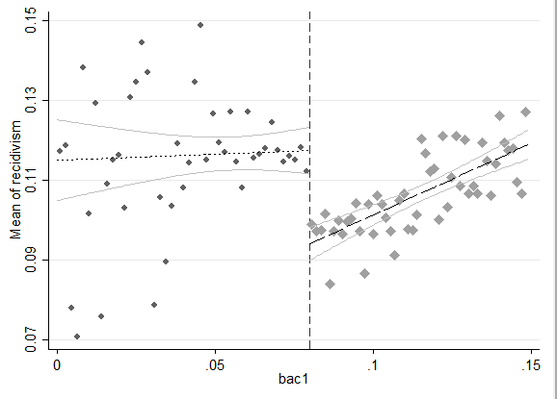Fit linear fit using only observations with less than 0.15 bac on the bac1

Figure 11. Recidivism linear fit.

* 1. Fit quadratic fit using only observations with less than 0.15 bac on the bac1

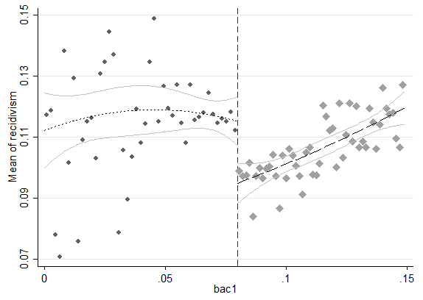

Figure 12. Recidivism quadratic fit.